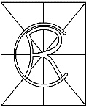
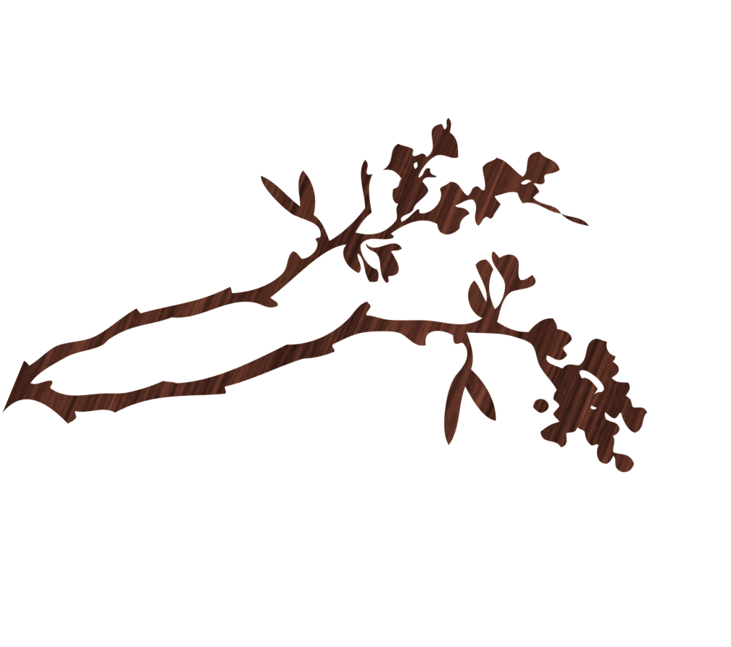Rosscarrock Community Association
for more information contact: Lauren @ (403) 242-0212

Annual meeting
May 30, 2017
7:00 pm
Community Hall
4411 10 Avenue SW
You are cordially invited to join us at our annual meeting.
PLEASE NOTE: This meeting we will also consider a Bylaw Special Resolution

